* div should divide the destination by the source
* look up meaning of DUP and when data segments start at certain addresses
* MAKE SURE PROGRAMMER CALCULATOR SAYS “WORD” FOR BINARY TO SIGNED INTEGER
  + “QWORD” FOR BINARY TO UNSIGNED
* two’s compliment of an integer is reversing (inverting) the bits and adding 1
* a 0-integer sign means positive, 1 means negative
* a word on x86 systems is 16 bits, doubleword is 32 bits
* largest unsigned integer that can be stored in 24 bits is 16,777,215
* extended index registers are ESI and EDI
* control bus uses binary signals to sync actions of all devices attached to system bus
* if a clock oscillates 10 billion times per sec, a single clock cycle is 1.0 x 10 ^ -10 sec
* real-address mode allows for 1MB of memory, protected mode allows 4GB
* 3 steps of instruction execution cycle = fetch, decode, execute
* lowest 8 bits of EDX register is DL
* the assembler reads assembly language source file and produces an object file
* assembly language instructions are executed at RUNTIME
* 6 instruction cycle steps
  + fetch instruction
  + increment instruction counter
  + decode
  + if instruction requires memory access…
  + execute
  + output operand…
* MOV imm,mem / mem,mem / imm,imm are not allowed
* MOVZX is for unsigned integers, MOVSX is for signed
* when DumpMem is called, the ESI register contains the starting address of data
* DumpRegs displays the CPU flags and 32-bit registers
* EDX contains the offset of a character array when calling GetCommandTail
* WriteHex writes an unsigned 32-bit integer to standard output in hexadecimal format
* what is a single instruction that inverts bits 5 and 6 in BL without changing any other bits? xor bl,1100000b
* the following are allowed formats for the MUL and DIV instruction
  + MUL mem32
  + MUL reg
  + MUL mem16
  + MUL mem8
  + DIV mem32
  + DIV mem16
  + DIV reg
  + DIV mem8
* the sizes of the sign, exponent, and significand for a Single Precision x86 floating point num are 1, 8, 23
  + for Double Extended Precision x86 floating point num it is 1, 16, 63
* Advantages of stack params vs. register params
  + Stack params reduce code clutter
  + Stack params are compatible with high-level languages
* passing arguments to procedures on the stack is more flexible
* 0FEh or similar operands are simply “offsets” which means address
  + the 0 denotes it is positive, which would set the Sign flag, not any other flag since no real calculation is being done
* mov al, 9ch not al = 63h

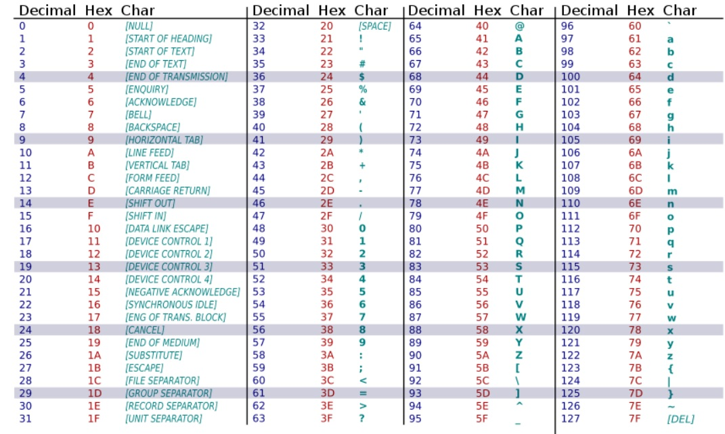

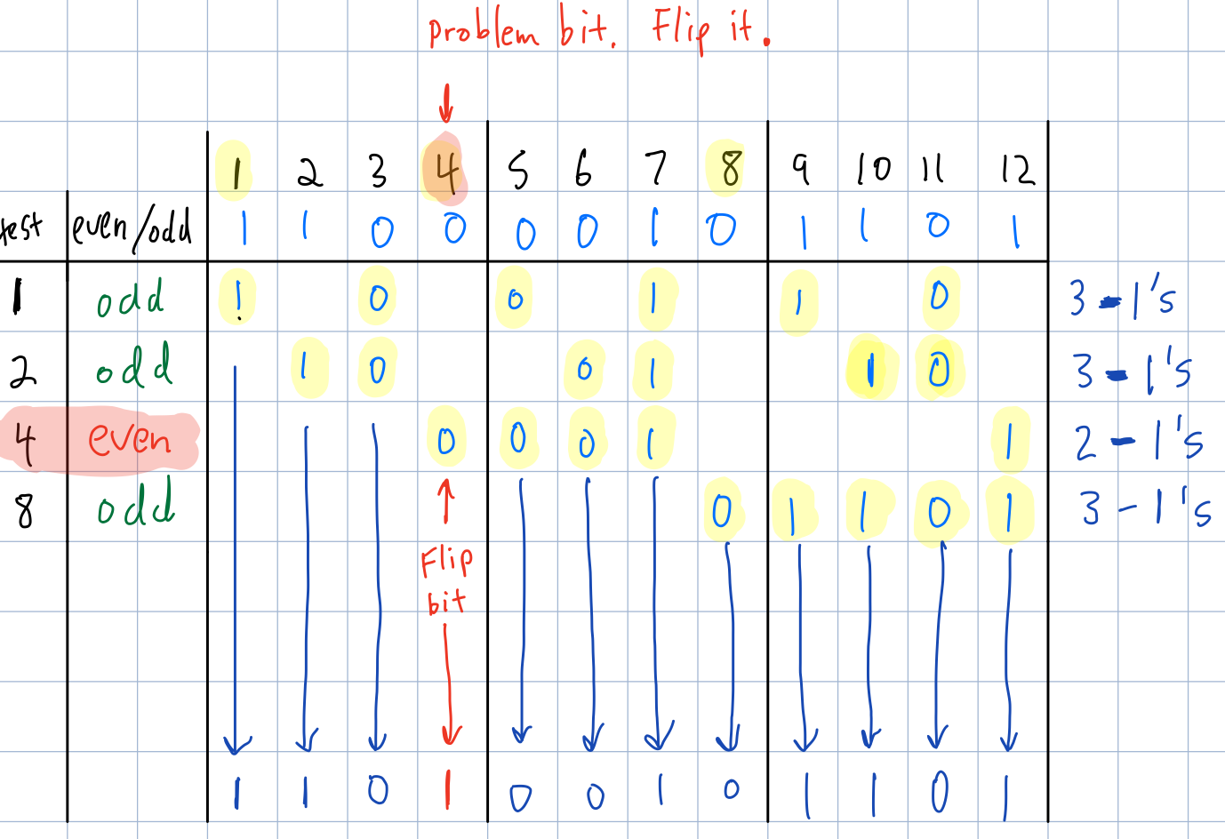

I use this table as a template. If there's only one bit that isn't the parity it's supposed to be (in this case even), then that is the problem bit and you just flip it.  If there's more than one, e.g if both 1 and 4 were even in an ODD parity test, then you would add 1 and 4 (5) and that's your problem bit. Then just flip that bit and you'll have the uncorrupted hamming code.